Market Update
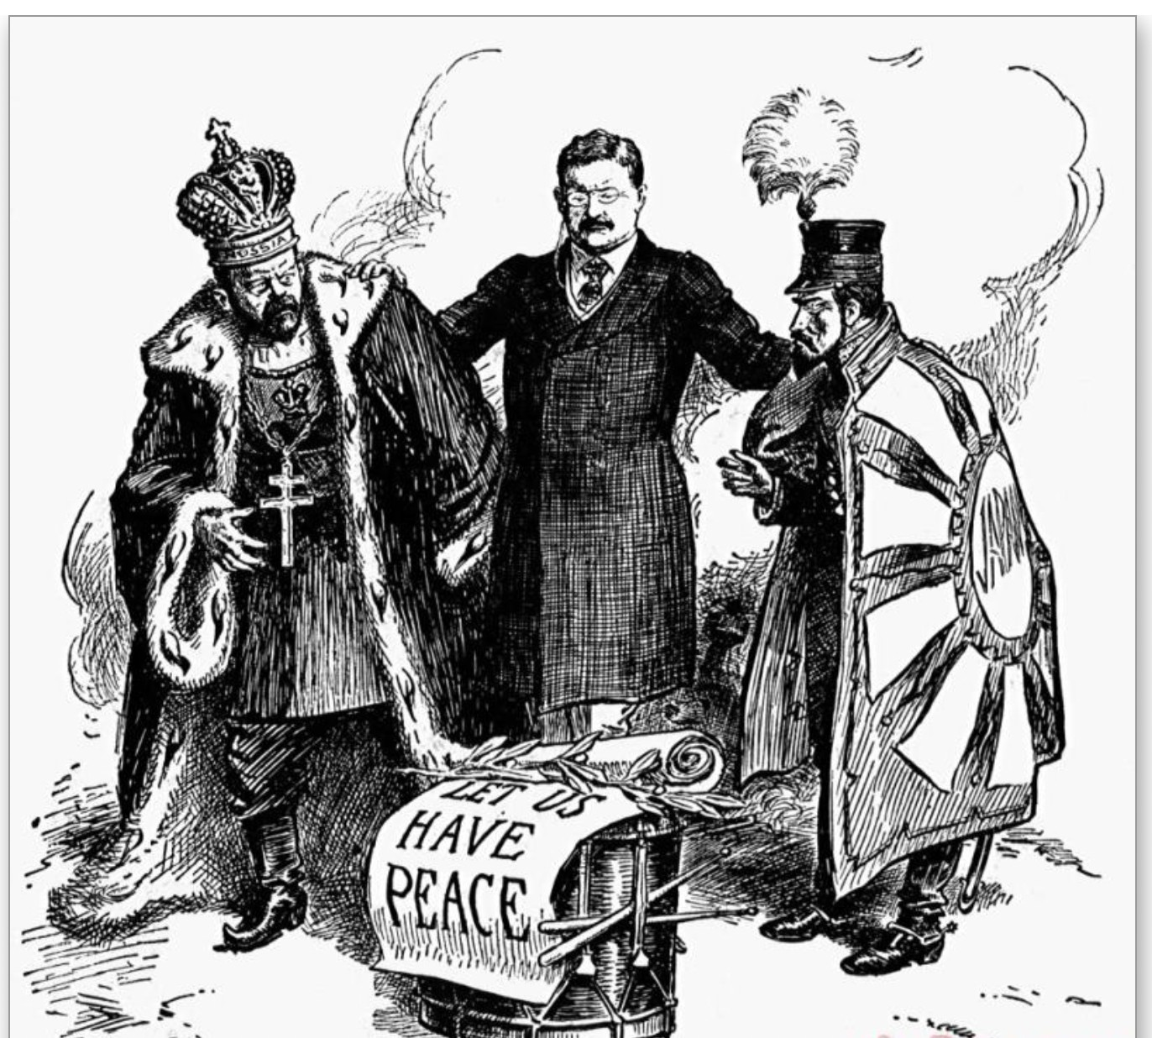
US President Teddy Roosevelt brokering the Russo-Japanese War Peace Talks in 1905

Lessons that history teaches
us about the current Ukraine crisis

By Bruce VonCannon

March 28, 2022

The Voice for Reason
Comments and Views for the Individual Investor

(March 28, 2022) The art appearing on the cover of this month’s edition dates back to 1905 when the 26th U.S. President, Teddy Roosevelt, moderated peace talks at the site of the naval shipyards located at the U.S. New England coastal city of Portsmouth, New Hampshire following a bitter series of land and sea battles over the course of 18 months off the Manchurian peninsula.

The war that broke out in February 1904 between one of Europe’s great land power armies, Russia, and a nascent power from Asia, Japan, is considered the first all-out war of the modern era and marked the first time that a non- European army defeated one of Europe’s great powers. It was a stunning defeat for the Russians, their army having entered the war with Russian leaders supremely confident but, in fact, fielding an army poorly supplied and badly managed (does that sound familiar?). This military venture also proved to be an eventual death knell for Russia’s Czarist leadership under the Romanovs who would nearly be deposed by a revolutionary uprising later in the same year and then overthrown following the outbreak of the October Revolution in 1917 and Russia’s hasty withdrawal from World War I. In the latest reckless adventure by the Russian military into Ukraine which began the morning of February 24th, it is looking more like 1905 than the Russian victory at Stalingrad in 1943.

At the outset of the 20th century, the United States was considered a rising global power (with some similarities to China today) although still secondary to the United Kingdom and its colonial empire in terms of global geo-political influence. By 1890, GDP in the U.S. had already surpassed that of the United Kingdom, and its fortunes would continue to rise in global prominence over the course of the next 60 years following the horrific global conflicts of World War I (1914-18) and World War II (1937-45) which so weakened the UK economy and manpower reserve. Spared of destructive land battles on the North American continent, the U.S. played a pivotal role in both wars applying its mighty manufacturing capacity into economic aid, its militarily prowess as well as its supply chain capability that would prove to be decisive. Near the end of World War II at the July 1944 Bretton Woods Conference, the U.S. dollar would supplant the British pound as global reserve currency - a de facto role that has survived to this day 77 years later. At the end of 1945, the U.S. constituted 50% of global manufacturing and possessed half of the world’s gold supply. By the way, President Teddy Roosevelt won the 1906 Nobel Peace Prize for his diplomacy in bringing an end to the conflict between Russian and Japan.

This marks the first outbreak of a large-scale land war on European soil since
World War II erupted 83 years ago.1 The world has become destabilized by this
sudden act of aggression which has caused significant military and civilian deaths as well as massive destruction to Ukraine’s infrastructure. To the surprise of many, the Ukrainian military and its Territorial Defense Force has held its ground in the first 4 weeks of war against a larger and better equipped Russian army. The Ukrainian will to fight, however, as well as the global response to such aggression by NATO and many members of the United Nations, has enabled Ukraine to force the invasion’s momentum into a stalemate in the fourth week of fighting.

Russian leader, Vladimir Putin, now in his 22nd year as head of state and ruling without many (if any at all) checks and balances, appears to have made a serious miscalculation. He clearly expected to achieve the objective of overthrowing the Ukrainian leadership and suppressing the population within 72 hours via a lightning blitzkrieg maneuver. Putin’s actions appear in retrospect to have been a very poorly planned and can only be viewed to be a strategic failure for both his leadership and the Russian military establishment.

What are the longer term implications of war in Ukraine?

The story in Ukraine has not fully played out. It may take weeks, if not months, for there to be a conclusion to the current war. What is clear is that the

1 World War II erupted on the European continent in September 1939 when Nazi Germany invaded Poland. Over the course of the ensuing 6 years of war, it resulted in the death of over 65 million military personnel and civilians and countless millions of dollars of property damage in war torn areas.

post-1989 world order following the fall of the Berlin Wall is now being challenged by a mindset within a Russian leadership who cling to the view of a Russia reinstating the old USSR borders or pre-20th Century Czarist Russian Empire. The reality, however, is that the reckless actions of the Kremlin have re-invigorated the 73-year-old NATO Alliance and the rules-based order it was created to preserve just at a time when, a mere 18 months ago, it seemed to be experiencing its most weakened decade of existence since its foundation.

Where is the smart money going amidst the outbreak of this conflict and the impact it will have on the global economy?

Prior to the outbreak of hostilities by the Russian army, year-to-date global
equity markets had already been trending downward by 10% as the specter of higher inflation and rising interest rates caused a sharp drop especially in tech and healthcare sectors. However, following the start of the invasion, the global equity market index dropped another 5% in the first week of the conflict. The Euro plummeted by 5% versus the U.S. dollar. Gold prices jumped 6%. Oil prices soared 30% and (more ominously) the price of wheat escalated from $8/ bushel to $12/bushel. Ukraine is one of the world’s largest exporters of key food commodities such as wheat, corn and sunflower oil, and its harvests will surely be impacted by the war. The massive global economic sanctions being imposed upon Russia will create disruptions in oil, gas, and fertilizer supply chains. Western Europe had grown more dependent upon Russian oil and gas
over the past two decades, particularly Germany and Italy.2 Such rising energy
and food prices continue to inflame inflationary pressures in the global economy and will likely shave points off the global GDP growth.

Even prior to the Russian invasion at the end of February, year-on-year inflation in the United States was touching a 40-year high at 7%. Analyst opinions had been divided as to whether the prevailing inflation rate would be transitory or was becoming more endemic. However, the war in Ukraine and its impact on markets have shattered the view that inflation can easily be contained under 6% this year. Look for at least three rate hikes in U.S. Dollar short term rates by the U.S. Fed and its Open Market meetings this year. As cost of borrowing rises, companies that have industry sector leadership and can

2 Germany imports 33% of its oil, 45% of its coal, and 55% of its natural gas from Russia. Italy imports over 45% of its gas from Russia. (Source: Aljazeera News)

pass along increase costs of production to customers will be better value for investors’ portfolios. On foreign exchange markets the U.S. dollar index (DXY), which measures dollar strength versus other major global currencies, rose nearly 3% following February 24th and has settled to just under the 99 level as investors continue to seek the safe haven status of the US dollar.

Investors should keep in mind the merits of maintaining a diversified portfolio during historical moments like these. A diversified asset allocation is the best protection against such volatility. While bond and equity prices gyrate (already underperforming during most of 2021), adding alternative asset positioning into one’s portfolio can help lower volatility and preserve the portfolio’s value.
Adding portfolio exposure to themes that include precious metals, oil and gas, and agribusiness sectors should be considered. While energy prices seem to garner much attention daily in news reports, food price inflation in the coming year is likely to be even higher than oil and gas. One is likely to see massive investment in defense spending and non-fossil fuel energy sources by NATO member countries. In just a matter of three weeks, NATO has announced a re- set on its geo-strategic defense posture. Germany alone will double its defense spending in the 2022 budget to EUR 100 billion.

How Does China’s leadership see this historic moment?
The analogy to Teddy Roosevelt may be useful for us to consider. Professor Stephen Kotkin of the Hoover Institute at Stanford, noted for his books and teachings on Russian history, stated in a recent interview with The New Yorker that three people in the world were probably capable of exercising some influence over Vladimir Putin and bringing a close to the war in Ukraine. One of those three persons, according to Kotkin, is President Xi Jin-Ping.3

China’s standing in the world today is similar to that occupied by the United States at the outset of the 20th century. On its current path China could potentially replace the U.S. in terms of global GDP ranking within the next 5-8
years.4 While China’s current currency policies with the RMB make it unlikely

3 In addition to President Xi, Koktin has noted Putin maintains close ties to Israeli Prime Minister Naftali Bennett as well as Finnish President Sauli Niinisto.
4 China’s annual nominal GDP at USD 18 trillion ranks slightly less than global leader USA at USD 21 trillion.

the it could replace the U.S. dollar as global reserve currency, the economic leverage that China has over Russia is enormous. China’s economy is roughly eight times larger than the Russian economy.5

The question is, does President Xi see himself as a neutral party like President Roosevelt did and seek to act in the interests of the innocent civilians and soldiers on both sides who are dying daily on Ukrainian soil. Or, is Xi committed to an alternative diplomatic path that changes a 60-year trend of detachment (and at times outright hostility) to Moscow?6 Is Xi committed to
re-aligning China’s strategic interests with those of Putin? The Xi-Putin summit that occurred in Beijing just prior to the start of the Beijing Winter Olympic Games gave the impression of an altered course in China’s diplomatic direction when a post-conference statement was issued proclaiming the Sino-Russian friendship “had no limits.”

However, the catastrophic ineptness of the Russian military’s invasion into Ukraine as well as the wanton slaughter of civilians and destruction of infrastructure in Ukrainian cities by Russian missile strikes will likely create tensions within Beijing policy discussions. Has the Beijing leadership correctly assessed the longer-term risks to China’s continued economic growth and global standing if they openly support the Putin regime? At its core, the Ukrainian crisis is the result of the worsening domestic political environment that has emerged within Russia since its 2012 elections and the wave of assassinations and persecution of political opponents occurring within Russia under Putin’s leadership. However, Putin’s iron fisted grip on leadership within Russia has been irreparably damaged following his reckless foray into Ukraine, and the historical legacy of Russian governments falling from power after

5 Russia’s annual GDP stands at about USD 2 trillion, roughly 1/8th that of China and 1/10th that of the USA.
6 During a seven month period beginning in March 1969 China’s PLA and the USSR’s Red Army military fought an undeclared war in the form of a series of border skirmishes along China’s northern border near the Ussuri River in Manchuria. The hostilities resulted In the death of at least 50 Russian soldiers and 250 Chinese soldiers. During this period the Kremlin leadership deployed over one million Russian soldiers along its border with China which extends which extends over 2500 miles—————roughly half the length of the US northern border with Canada. This conflict resulted in the Maoist leadership adopting a sudden rapprochement with the United States and culminating with President Richard Nixon’s visit to China in 1971.

military setbacks is unmistakable.7 The stunning resurgence of unity within the NATO alliance with nations rallying support behind Ukraine and the swift imposition of diplomatic and economy sanctions against Russia will clearly register within policy discussions in Beijing. U.S. President Biden noted in a recent press release that “We are at an inflection point….in the world economy.” Larry Fink, CEO of world’s largest asset manager, BlackRock Inc. (US$10 trillion in AUM), has lamented, “The Russian invasion …. has put an end to the globalization we have experienced over the last three decades.”

Can the rules-based world order established by the United Nations at its inception in 1945 survive? Is the flirtation with Putin’s Russia a strategic re-set for China or merely a temporary misjudgment from which Beijing leadership will figure out over time to disengage themselves? Historically speaking, the seminal moment is upon us, and the jury is still out.

======================

7In addition to military defeat and the fall of the Romanov Dynasty following in the early 20th Century, Russian governments have changed hands following Khrushchev’s perceived setback two years after the Cuban Missile Crisis in 1964 and the dissolution of the old Soviet Union in 1991 two years after the Russian military’s humiliating defeat following a 10 year war in Afghanistan.

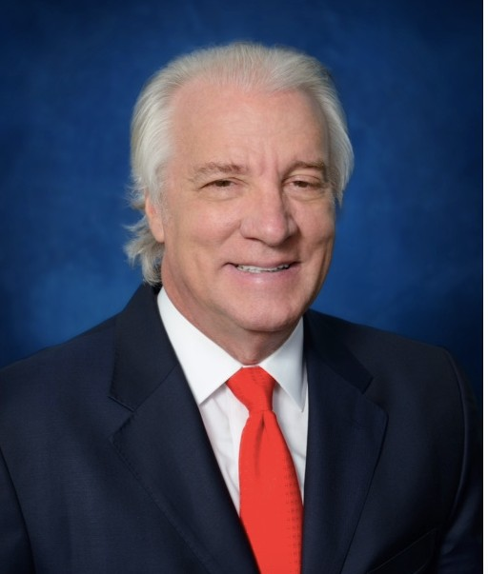

About the author:
Bruce VonCannon is a native of North Carolina USA and currently a Managing Director with Vanheel Management Ltd., a Hong Kong SFC
and U.S. licensed independent asset management firm founded in 2002. His career spanning 27 years in international banking and wealth
management has included assignments in New York, Taiwan, Hong Kong, Singapore and Geneva. He is an author and frequent speaker at financial seminars, universities, and business forums. His latest book, “Status Anxiety: Hong Kong’s Crisis of Identity” was recently released in hardback and e-book copy by Palgrave MacMillan.

